**Developing stem taper of *Shorea robusta* in the far-western Terai of Nepal**

# Abstract

Tree taper functions expressed in terms of height and diameter at breast height (BDH) can provide accurate and timely information on current growing stock. Taper equations are very important for calculation of growing stock in forest inventories, however, in the context of Nepal, these are still unavailable at the required level. The study aimed to develop taper equations, so that those can be used to predict the diameter anywhere along the stem, and estimate tree volumes at desired sections. The input data was a destructive sampling method of 81 sample trees of *Shorea robusta* distributed in ten locations of the far western Terai of Nepal (Kailali and Kanchanpur districts).

Using two independent *B-Spline* and *5th-degree polynomial* taper models, the upper stem diameters were imputed. Both models were applied on the whole dataset, irrespective of DBH size, to get common fitted taper models. Later, the same models were tested for three different DBH classes to compare and evaluate the best-fit model.

Taper models, developed under the B-spline polynomial model of 3rd degree, were found to be highly dependent on the tree (DBH) sizes. Thus, better models could be developed by classifying the whole dataset based on different DBH classes. On the other hand, developed models under the 5th degree polynomial taper model did not exhibit their dependency on the tree (DBH) sizes and a better model was found for the unclassified datasets, i.e. for all DBH sizes.

*Keywords: stem taper, Shorea robusta, Terai*

# Introduction

For efficient forest management, accurate and up-to-date information on current growing stock and future growth potential is required. Tree taper functions expressed in terms of height and diameter at breast height (DBH) can provide accurate and timely information on current growing stock (Muhairwe, 1999). The stem taper function is thus considered a basic input for forest planning and management (Kublin et al., 2013; Heidarsson & Pukkala, 2011). Form factor gives a basic idea of a tree's form or shape. However, it doesn’t express how the diameter narrows as the tree height rises. A taper equation can best provide such information by providing a relationship to predict a tree's stem diameters at desired section. Modelling stem taper thus provides the key input to derive upper stem diameters and calculate stem volumes at any height. Stem taper is defined as the relative rate of change in stem diameter as tree height increases and can be expressed mathematically (Kohler et al., 2016). Various methods have been proposed for developing taper equations. Several studies have primarily focused on softwood tree species for developing taper equations (Max & Burkhart, 1976; Fang et al., 2000). However, only a few taper equations have been developed for hardwoods (Ounekham, 2001). *Shorea robusta*, a hardwood species from the Dipterocarpaceae family, has been chosen for this study. It is a common species found abundantly in Nepal's Terai and Siwalik regions (DFRS, 2014). Due to its strong and long-lasting wood, the species is considered a valuable and multipurpose tree and is thus a recognized a primary timber source in the Nepalese market. It is a large tree that grows to 45-50m tall and is found in deciduous forests up to an altitudinal range of about 1,500m (though it is uncommon above 1,000 m) (Jackson, 1994). Despise their usefulness, volume and taper function have been rarely studied in Nepal. Due to the lack of local taper equations, the forest resource assessment of Nepal has estimated volumes of broken trees based on the taper equations developed by Heinonen et al. (1996). These polynomial taper equations were prepared using the data from exotictree plantations in Zambia. This study seeks to develop taper equations, which can be used to predict the diameter anywhere along the stem, and estimate tree volumes at different desired sections for growing stock calculation for national and other local scale forest resource assessment.

# Materials and methods

## Study Area

This research used the data collected from 10 locations of the far western Terai of Nepal (Kailali and Kanchanpur districts of Sudur Pashchim province). The area is located between the latitudes of 28.8314o and 28.8372 o N and the longitudes of 80.8987 o and 80.3213 o E (Figure 1). The region extends from the Karnali River in the east to the western border of the country, where the forest area covers 97,622 ha outside the protected area (DFRS, 2014). The elevation of the study area covers an altitudinal range of 109 m to 200 m above msl. The climate varies from sub-tropical to tropical. The total annual precipitation ranges from 1130 mm to 2680 mm (DFRS, 2014). This region is characterized by hot summers (more than 40 °C in peak summer) and dry winters (less than 15 °C). The native forest type in the region is comprised of Terai mixed hardwood forest with the dominancy of *Shorea robusta.*

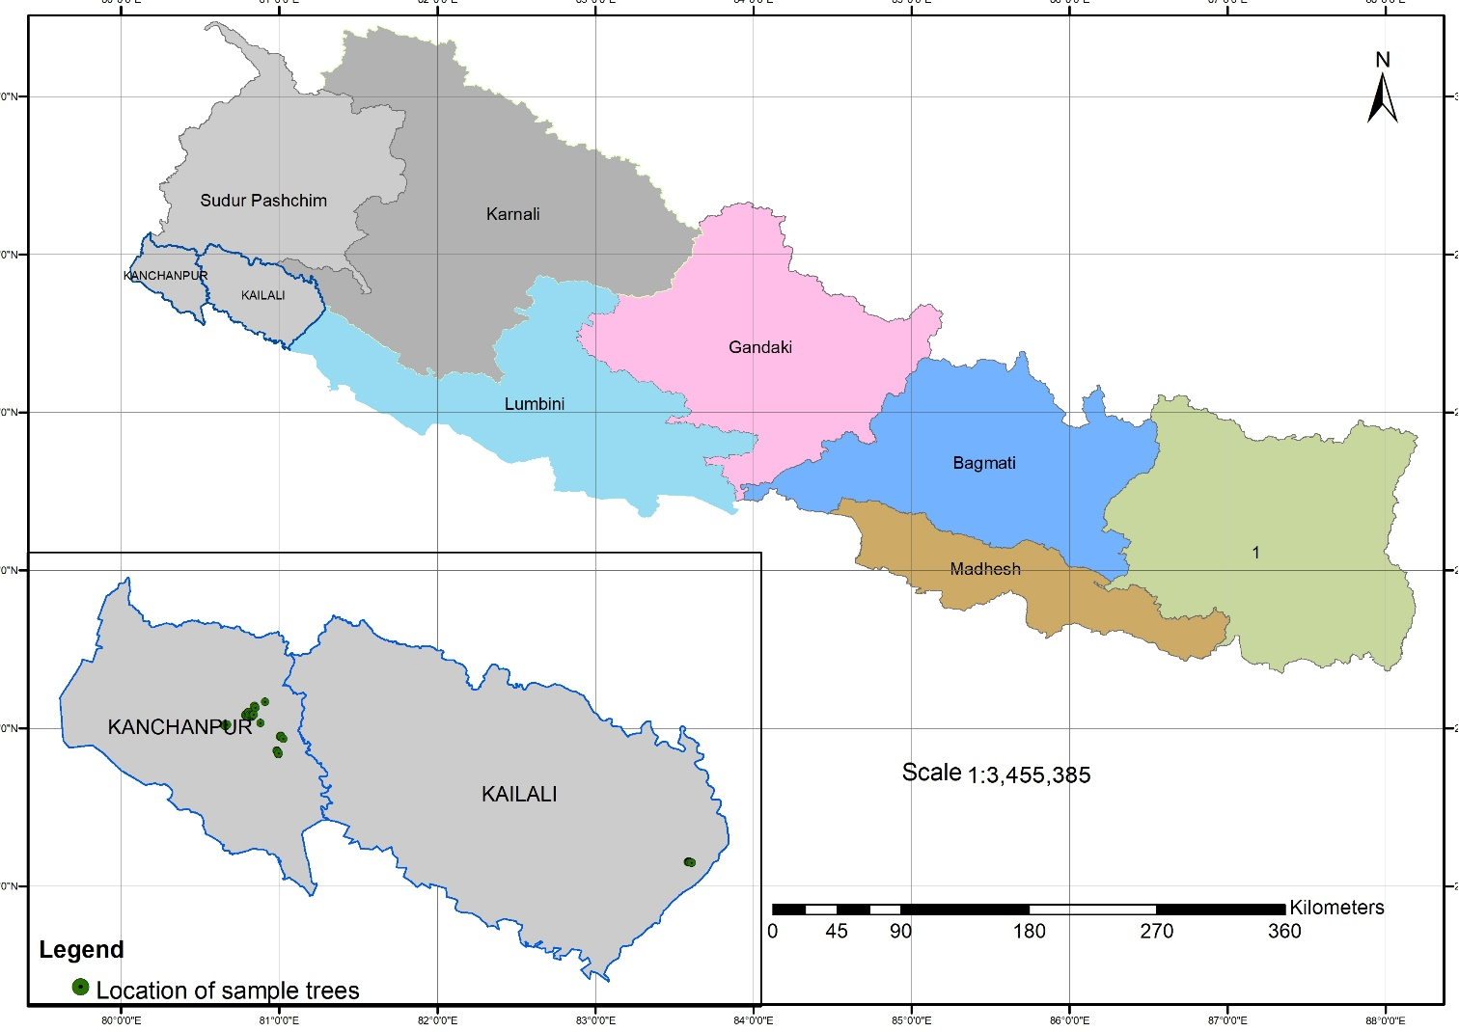

Figure 1: Map of the study area.

## Data collection

The data collection was done as an annual program of the Department of Forest Research and Survey that aimed to **prepare of local volume tables for *Shorea robusta*** in 2018. The data consists of 81 sample trees of different DBH (over bark) classes (Figure 2). A destructive sampling approach was adopted to measure the data.The recorded tree characteristics before felling trees included tree height, diameter at breast height, crown height, location, and height from base to the diameter measuring points at several sections of stem.

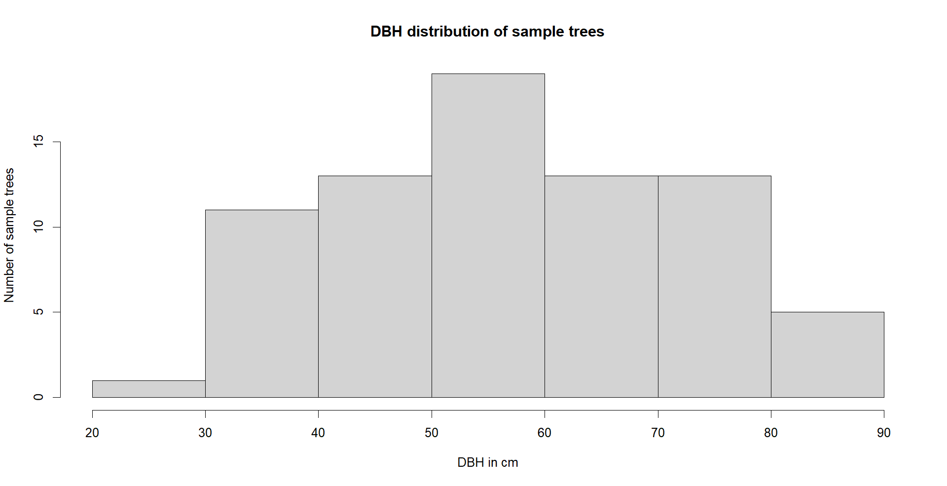

Figure 2: Histogram showing DBH classes of sample trees

The over bark diameters were measured at an interval of 0.5 m in the lowermost three sections, at an interval of 1 m for one section and an interval of 2 m in the upper part of the trunk, following Sharma and Pukkala (1990) and Eerikäinen (2001). Thus, the upper stem diameters (over bark) were measured at the following heights (in m) from the base of each tree: 0.3, 0.8, 1.3, 1.8, 2.8, 4.0, and every 2m until the tip of the trees (Figure 3), all those diameters were measured by a diameter tape with an accuracy of 0.1 cm (Subedi, 2017).

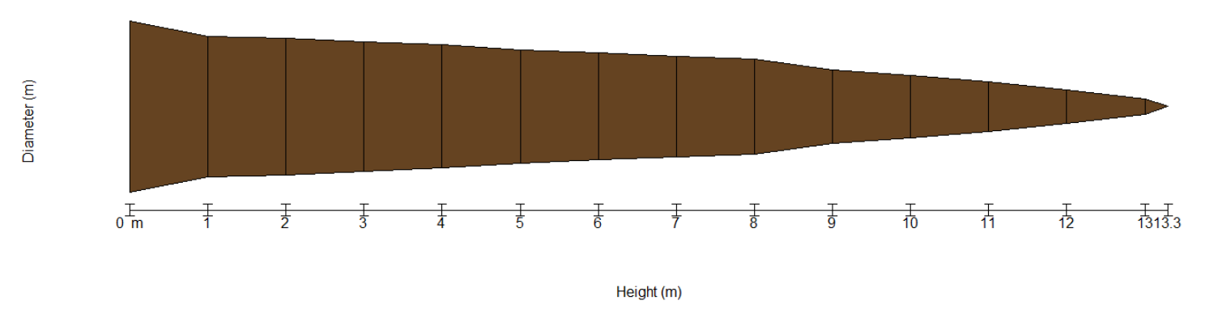

0.3

0.8

1.3

1.8

2.8

4.0

6.0

10.0

8.0

12.0

13.3

Figure 3: Diameters measurement points along the tree stem

All trees with serious defects and abnormalities were excluded from the sampling frame. Observation of tree stem diameters (cm) at different height (m) from the base for all samples is presented in Figure 4.

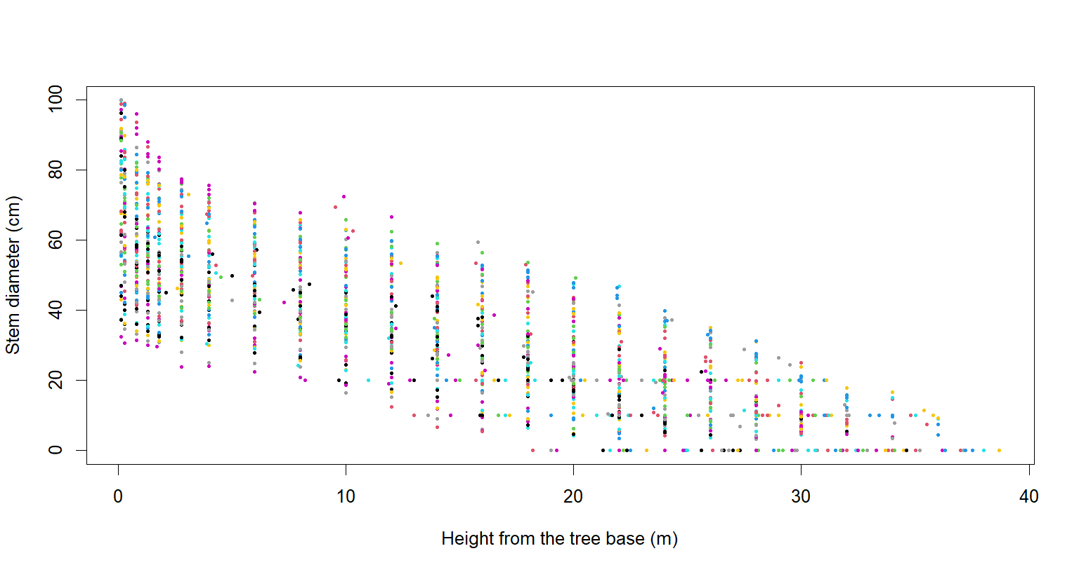

Figure 4: Observation of stem diameters (cm) at different height from the base (m), colours represent different trees.

## Data analysis and tools

Stem taper functions were used to model the relative decrease of diameter (Dx) as the relative height (Hx) increases. As the reference diameter defines the relative value, possible options are the maximum value along the stem or the diameter at breast height (DBH). However, the relative decrease in diameter should be referred to as a directly measurable and easy-to-access parameter. The relative diameter, upper stem diameter (Dx), measured at each sampling height (Hx), was modelled as a function of the relative height (x) of the tree. The following two independent modelling approaches were followed to develop stem taper equations:

1. **B-spline cubic polynomial model**

Spline interpolation is a mathematical method commonly used to construct new points within the boundaries of a set of known points. These new points are function values of an interpolation function (referred to as spline), consisting **of multiple cubic piecewise polynomials. Cubic spline** has a continuous second derivative, while **quadratic spline** only has a continuous first derivative. Thus, **cubic spline is** smoother and was chosen (Equation 1).

Y= a + b*X+cX2+dX3  (Equation 1)

Where,

a, b, c and d are equation parameters

X is the independent variable, i.e. ratio of upper stem diameter and DBH

Y is the dependent variable, i.e. upper stem diameter in cm

1. **Polynomial 5th degree**

This modelling approach was based on functions implemented in rForest package that allowed to fit this taper mode (Equation 2)along with by visualization in 2D and 3D (Silva, 2021). The

I(di/dbh) ~ I(x) + I((x)^2) + I((x)^3) + I((x)^4) + I((x)^5)) (Equation 2)

Where,

di/dbh is a ratio of upper stem diameters to tree DBH

I(x)n are equation parameters

Two independent models, B-Spline and polynomial 5th-degree, were initially tested for sample including all DBH size trees. Later, both models were tested for three different DBH classes, and the model outputs were compared to find the best fit model. Several R packages, e.g. splines (R Core Team, 2022), rForest (Silva et al, 2021), tidyverse (Wickham et al, 2019), ggplot2 (Wickham, 2016), etc. were used for data analysis and visulalization.

# Results

## B-spline cubic polynomial

The equation parameters of the B-spline cubic polynomial taper model (equation 1) and fitted lines are illustrated in figure 5. The developed models for different DBH classes had the measured goodness of fit (adjusted R2) of 0.8, 0.90, and 0.96, respectively, for below 50 cm, 55-70 cm, and greater than 70cm. Whereas the adjusted R2 was 0.78 for the model developed for the whole dataset irrespective of size (DBH) class (Table 1).

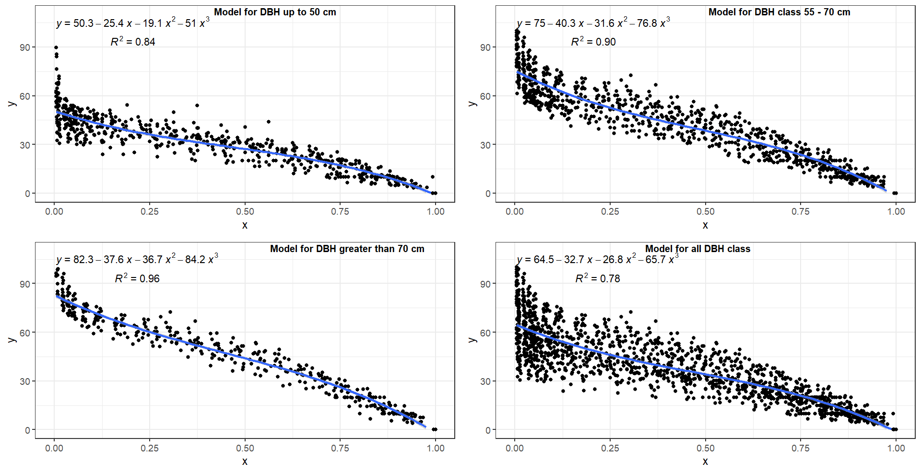

Figure 5: B-spline cubic polynomial taper models

The B-spline cubic polynomial taper models developed independently for different DBH classes have lesser standard errors with higher adjusted R2. On the other hand, a single taper model developed for all DBH sizes has a greater standard error with a lower adjusted R2 than the former ones.

Table 1: Estimated parameters of B-spline cubic polynomial taper models

|  |  |  |  |  |  |  |  |
| --- | --- | --- | --- | --- | --- | --- | --- |
| SN | DBH class (cm) | a | b | c | d | SE (residuals) | Adj.R2 |
| 1 | < 55 | 50.3 | -25.4 | -19.1 | -51 | 6.25 | 0.84 |
| 2 | 55 – 70 | 75 | -40.3 | -31.6 | -76.8 | 5.48 | 0.90 |
| 3 | > 70 | 82.3 | -37.6 | -36.7 | -84.2 | 8.87 | 0.96 |
| 4 | All DBH size | 64.5 | -32.7 | -26.8 | -65.7 | 12.85 | 0.78 |

## Polynomial 5th degree

The model built for the DBH classes < 55 cm, 55-70 cm, and > 70 cm predicted a large deviation from the observed value, although the outcome varied for each of the three DBH classes. However, the standard errors for each model parameter of the model developed for all DBH classes were smaller than that for different DBH classes (figure 6).

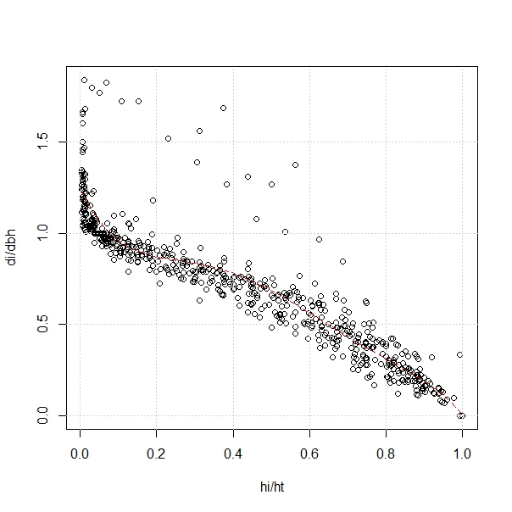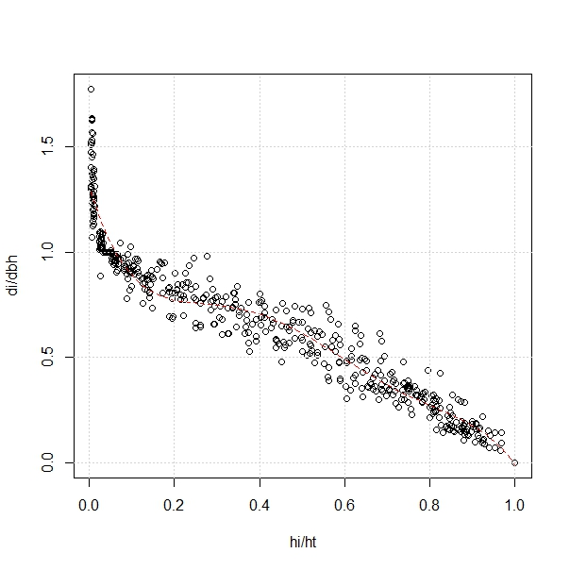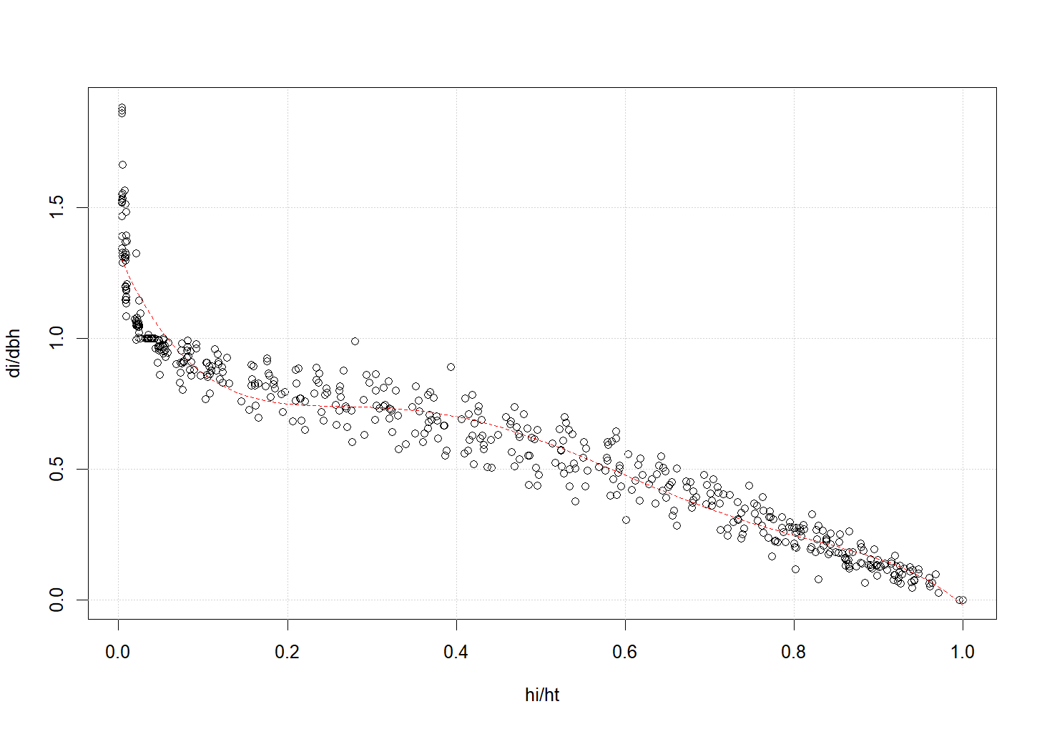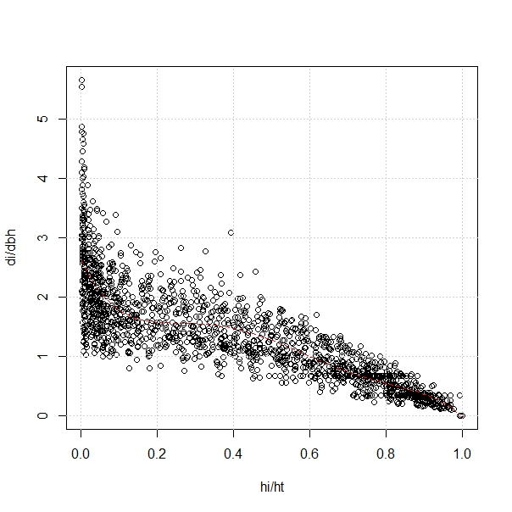

Model for DBH < 50 cm

Model for DBH 55 - 70 cm

Model for DBH > 70 cm

Model for all DBH sizes

Figure 6: 5th degree polynomial taper models

# Discussion

The changes in diameter and height growth along the stem over time cause the taper variations between different trees. Several factors influence tree taper, viz. diameter and height, including genetic make-up, climate change, site quality, tree and stand age, crown size, canopy position, defoliation, species, and stand density (Muhairwe, 1999). According to Muhairwe (1999), one reason is that there is no single taper model that works best for all applications, and there is no one theory for taper equations that can be applied effectively for all tree species (McClure & Czaplewski 1986); another reason is that taper equations must be more precise and adaptable in their predictions.

Different researchers have presented various tools and techniques to define and evaluate different models, out of which components of fit statistics and graphical inspection have been mostly considered (Kozak & Kozak, 2003; Bellocchi et al., 2010). In addition, some authors calculated the prediction statistics of independent data sets for model validation, e.g. (Vanclay,1994), while a few authors also strongly recommended checking independent trees to measure the accuracy of the models (Ducey & Williams, 2011). In this study, we tried a different approach for developing taper models. Two independent models: i) B-spline cubic polynomial and ii) Polynomial 5th degree, have been used to develop taper models for *Shorea robusta.* Firstly, we classified the data according to different DBH classes and applied both models to generate taper equations. Later, the same two taper models were used to develop taper equations for unclassified data, i.e. for all DBH size classes. And finally, for each taper model. We compared those equations developed for classified data (based on DBH size) with those developed for unclassified data (all DBH size).

Differences in taper for trees result from differences in diameter and height growth along the stem over time (Muhairwe, 1999). In this study, we also found taper models developed under B-spline cubic polynomial following the similar trend where models developed under the different DBH classes were better fitted than those developed for all DBH sizes. Splines provide more fitting flexibility without adding as many fixed parameters, which may improve the representation of the stem form variability that is frequently present in some species, particularly hardwoods or softwoods with prominent stump flare (Kublin et al., 2013). Furthermore, cubic spline interpolation is considered a better approximation since it is less prone to larger oscillations at knots due to Runge's phenomenon (Fornberg & Zuev, 2007). Since spline interpolation was used to categorize the entire dataset based on three DBH classes, it demonstrated stronger performance and increased versatility. In contrast, a similar relationship was not observed for taper models developed under the 5th-degree polynomial (rForest) model. In this model, a better-fitted model was found for all DBH sizes than those developed for the three different DBH classes. Thus, this approach to develop taper models that included input data from varying tree sizes exhibited a better representation of tree variabilities, mainly the size class. The findings agree with the observation from a research in Brazil where authors demonstrated better results and thus favors the fifth-degree polynomial as a taper model (Téo et al., 2018).

# Conclusion

The findings confirmed that the taper models were highly dependent on the tree (DBH) sizes and, the best-fit taper models could be developed by classifying the dataset representing different DBH classes. The modelling using the B-spline polynomial model of 3rd degree offered a better fit. On the other hand, since better results could not be obtained by classifying the whole dataset into different DBH classes and the taper models were seen as dependent on the tree (DBH) sizes, the best-fit taper model could be developed by not disintegrating the dataset into different DBH classes for modelling under 5th-degree polynomial taper model.

# References

1. Bellocchi, G., Rivington, M., Donatelli, M. & Matthews, K. (2010). Validation of biophysical models: issues and methodologies. A review. Agronomy for Sustainable Development 30 (1): 109--130.
2. DFRS (2014). Terai Forests of Nepal. Forest Resource Assessment Nepal, Department of Forest Research and Survey (2010-2012).
3. Ducey, M. J. & Williams, M.S. (2011). Comparison of Hossfeld's method and two modern methods of volume estimation of standing trees. Western Journal of Applied Forestry 26 (1):19-23.
4. Eerikäinen, K. (2001). Stem volume models with random coefficients for *Pinus kesiya* in Tanzania, Zambia, and Zimbabwe. Canadian Journal of Forest Research, 31(5), 879-888.
5. Eerikäinen, K. (2001). Stem volume models with random coefficients for Pinus kesiya in Tanzania, Zambia, and Zimbabwe. *Canadian Journal of Forest Research*, *31*(5), 879–888. <https://doi.org/10.1139/x01-019>.
6. Fang, Z., Borders, B. E., & Bailey, R. L. (2000). Compatible volume-taper models for loblolly and slash pine based on a system with segmented-stem form factors. *Forest Science*, *46*(1), 1–12.
7. Fornberg, B., & Zuev, J. (2007). The Runge phenomenon and spatially variable shape parameters in RBF interpolation. *Computers & Mathematics with Applications*, *54*(3), 379-398.
8. Heidarsson, L., & Pukkala, T. (2011). Taper functions for lodgepole pine (*Pinus contorta*) and siberian larch (*Larix sibirica*) in Iceland. *Icelandic Agricultural Sciences*, *24*(1), 3–11.
9. Heinonen, J., Saramäki, J., & Sekeli, P. M. (1996). A polynomial taper curve function for Zambian exotic tree plantations. *Journal of Tropical Forest Science*, 339-354.
10. Jackson, J. K. (1994). *Manual of Afforestation in Nepal.* Kathmandu:Forest Research and Survey Centre. 2nd edition.
11. Kohler, S. V., Koehler, H. S., Figueiredo Filho, A., Arce, J. E., & Machado, S. D. A. (2016). Evolution of tree stem taper in *Pinus taeda* stands. *Ciência Rural*, *46*, 1185-1191.
12. Kozak, A. & Kozak, R. (2003). Does cross validation provide additional information in the evaluation of regression models. Canadian Journal of Forestry Research 33(6): 976--987.
13. Kublin, E., Breidenbach, J., & Kändler, G. (2013). A flexible stem taper and volume prediction method based on mixed-effects B-spline regression. *European Journal of Forest Research*, *132*(5), 983-997.
14. Max, T., & Burkhart, H. E. (1976). Segmented polynomial regression applied to taper equations. *Forest Science*, *22*(3), 283–289.
15. McClure, J.P. & Czaplewski, R.L. (1986). Compatible taper equation for loblolly pine. Canadian Journal of Forest Research 16: 1272-1277.
16. Muhairwe, C. K. (1999). Taper equations for Eucalyptus pilularis and Eucalyptus grandis for the north coast in New South Wales, Australia. *Forest Ecology and Management*, *113*(2–3), 251–269. https://doi.org/10.1016/S0378-1127(98)00431-9
17. Ounekham, K. (2009). Developing volume and taper equations for *Styrax tonkinensis* in Laos. Master’s thesis, University of Canterbury, New Zealand.
18. R Core Team (2022). R: A language and environment for statistical computing. R Foundation for Statistical Computing, Vienna, Austria. URL: <https://www.R-project.org/>.
19. Sharma, E. R. & Pukkala, T. (1990). Volume Equations and Biomass Prediction of Forest Trees of Nepal.
20. Silva C, Klauberg C, Carvalho S, Rosa M, Madi J, Hamamura C (2021). _rForest: Forest Inventory and Analysis_. R package version 0.1.4, URL: <https://CRAN.R-project.org/package=rForest/>.
21. Silva C. A. (2021). Package “rForest” for Forest Inventory and Analysis. Set of tools designed for forest inventory analysis.
22. Subedi, T. (2017). Volume models for Sal (*Shorea robusta* Gaertn.) in far-western Terai of Nepal. Banko Janakari, 27(2), 3-11.
23. Téo, S. J., Machado, S. do A., Filho, A. F., & Tomé, M. (2018). Stem taper equation with extensive applicability to several age classes of Pinus taeda L. *Floresta*, *48*(4), 471–482.
24. Vanclay, J. K. (1994). Modelling Forest Growth and Yield. Application to Mixed Tropical Forest. CAB International, Oxon, UK. Iles, (2003); A Sampler of Inventory Topics. Kim Iles & Associates Nanaimo, BC, Canada.
25. Wickham H, Averick M, Bryan J, Chang W, McGowan LD, François R, Grolemund G, Hayes A, Henry L, Hester J, Kuhn M, Pedersen TL, Miller E, Bache SM, Müller K, Ooms J, Robinson D, Seidel DP, Spinu V, Takahashi K, Vaughan D, Wilke C, Woo K, Yutani H (2019). “Welcome to the tidyverse.” _Journal of Open Source Software_, *4*(43), 1686. URL: <https://doi.org/10.21105/joss.01686>.
26. Wickham, H. (2016). ggplot2: Elegant Graphics for Data Analysis. Springer-Verlag New York.